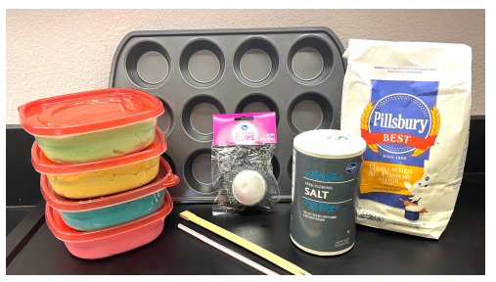
Teacher Prep
Each group will need the following:
- Plastic straw
- Prepared cupcake strata
- Plastic knife
- Colored pencils (colors should match the layers of playdough)
- Chopstick or glass stirrer (should be small enough to fit into a straw)
You will need to purchase or make 5 colors of playdough. A recipe is listed below. (No heat or cooking required. Add food coloring to water before mixing to help evenly distribute the color.)
- 2 cups flour - 2 tablespoons alum or cream of tartar
- 1 cup salt - 2 tablespoons vegetable oil
- 1 cup cold water - food coloring (5 different colors)
One 5lb bag of flour and two 26 oz containers is enough to last 5 classes, making 7 cupcakes per class. Overall, this made 4 batches of 5 different colors.
You can use anything that doesn’t dissolve in the playdough as fossils or artifacts. Some ideas include rice, lentils, sunflower seeds, Styrofoam balls from Dollar Tree, or anything you have laying around.
Layer the playdough into foil cupcake liners. You can do this in any order. One method is to mix the fossils with sandstone. Once 3 layers have been completed, take a knife and cut the cupcake in half, add a red (basalt) cross cut, and then place one additional layer on top (see image below). 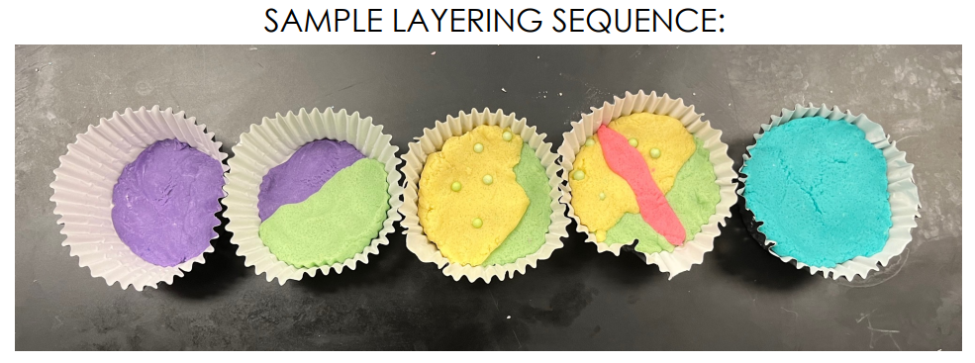
If you make the cupcakes all at once, place in a Ziploc bags or Tupperware containers to keep from hardening. Otherwise, layer a new set for each class.
Optional: Prior to this lab, students should have a basic understanding of relative data and the 4 stratigraphic laws associated with relative dating.
Background
Earth scientists use a process called stratigraphy to interpret rock layers and determine how they formed.
When analyzing, they follow these laws:
- Law of superposition: This law states that when sediments are deposited, the oldest is deposited at the bottom and the youngest sediment is on top.
- Law of original horizontality: When sediment is deposited, they form layers that are horizontal under the action of gravity.
- Law of cross cutting: Any strata that cut through other layers of rock are younger than the rock they cut. Geologists take core samples to analyze rock layers. During this process, they use special drills to extract a cylindrical section of rock into a hollow tube. These samples can be extracted thousands of feet deep.
In today’s lab you will be modeling this process using straws and playdough.

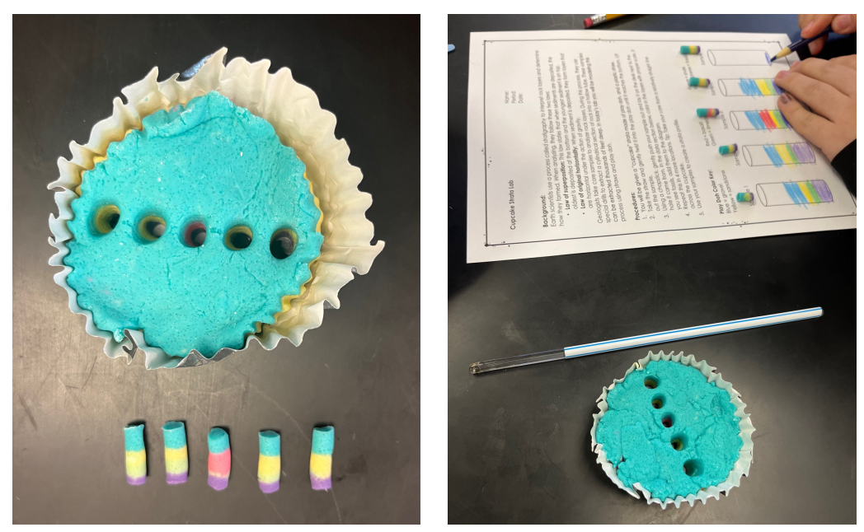

Procedures
Name: ___________________________________________ Date: _____________________________
Stratigraphy Lab
1. You will be given a “cupcake” strata made of play doh, and a plastic straw.
2. Take the straw and gently twist it into the play doh until it reaches the bottom. Lift out the sample. (Tip: If the playdough doesn’t come out when you lift the straw, try pushing it all the way through the liner instead. It is okay to break the liner).
3. Using a chopstick, gently push your sample out and lay it on the desk next to the hole it came from. In the data section below, color in the layers with proper scale. If you see fossils, add them to the diagram.
4. Repeat this in 4 more locations. Tip: Take your core from a straight line across the cupcake.
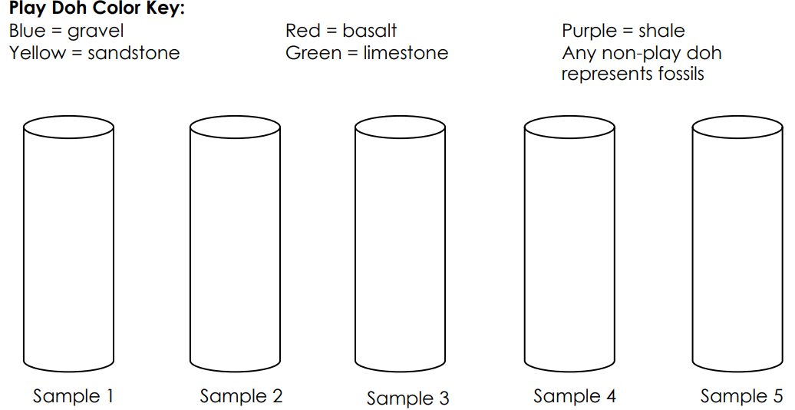
5. Use your samples to create a strata profile.
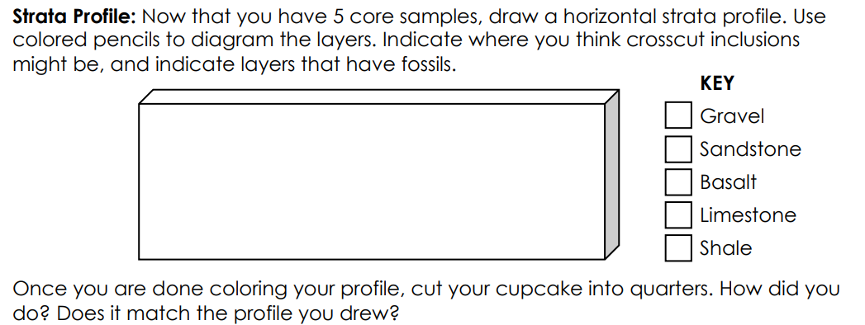

Post Lab Questions
1. How many rock layers did you find in your sample? ________________________
2. Which rock layer is the oldest? _____________________________________________
3. Which rock layer is the newest or youngest? ________________________________
4. Based on your cores, was sandstone or limestone deposited first? _____________________________________________________________________________
5. How does this demonstrate the law of superposition? ______________________________ _______________________________________________
6. What might cause strata to not be flat and horizontal? ______________________ ______________________________________________________________________________7. In which type of rock did you find fossils? ______________________________________________________________________________
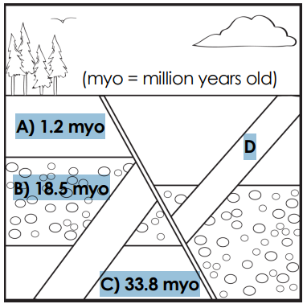
8. What might aquatic fossils tell you about the environment in that area? ______________________________________________________________________________ ______________________________________________________________________________ 9. How old is rock layer D in the diagram?
________________________________________________
How do you know? ________________________________________________ ________________________________________________ ________________________________________________
10.Which layer represents a crosscut? _____________
Which color of playdough in your model represented a crosscut? ___________________________

Post Lab Questions – ANSWER KEY
1. How many rock layers did you find in your sample? 5
2. Which rock layer is the oldest? WHICHEVER COLOR WAS AT THE BOTTOM
3. Which rock layer is the newest or youngest? THE TOP LAYER
4. Based on your cores, was sandstone or limestone deposited first? BOTTOM
5. How does this demonstrate the law of superposition? THIS SHOWS THAT THE HIGHER THE STRATA, THE YOUNGER THE ROCK LAYER
6. What might cause strata to not be flat and horizontal? SHIFTING TECTONIC PLTAES, HEAT AND PRESSURE
7. In which type of rock did you find fossils? (SHOULD BE IN A SEDIMENTARY ROCK)
8. What might aquatic fossils tell you about the environment in that area? THAT AREA HAD TO HAVE BEEN UNDER WATER AT SOME POINT IN TIME
9. How old is rock layer D in the diagram? How do you know? LAYER D IS A CROSS CUT, SO IT HAS TO BE YOUNGER THAN 1.2 MILLION YEARS OLD.
10.Which layer represents a cross cut? D
Which color of playdough in your model represented a cross cut? ANSWER DEPENDS ON YOUR MODEL.

