When sediment is deposited, they form layers that are horizontal under the action of gravity.
Law of Horizontality
This law states that when sediments are deposited, the oldest is deposited at the bottom and the youngest sediment is on top.
Law of Superposition

Law of Cross Cutting
Any strata that cut through other layers of rock are younger than the rock they cut.
Stratum/Strata
A layer or series of layers of rock in the ground. If there are many layers these are called strata.

archaeology
The study of human history through the things people made, used, and discarded.
archaeologist
A detective who studies the past by digging up and examining old objects that people left behind.
Stratigraphy
The study of layered rocks (strata) and their sequence in time and place.
artifacts
Something made and/or used by humans a long time ago.

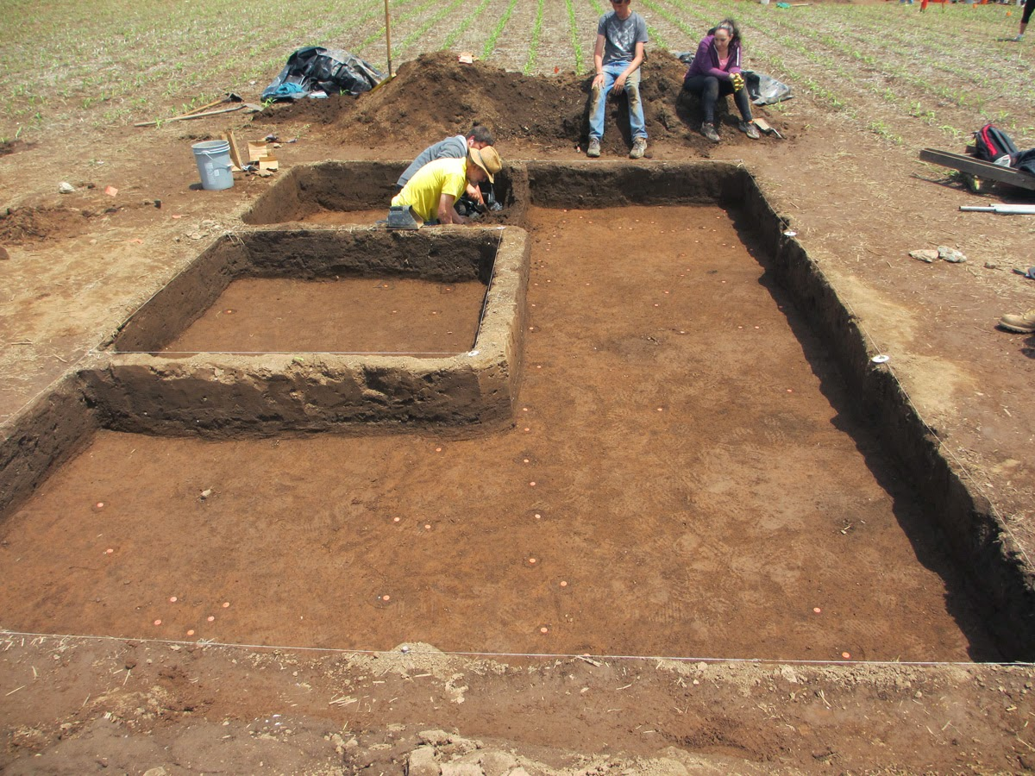
IMAGE 2
ccarchsoc.blogspot.com
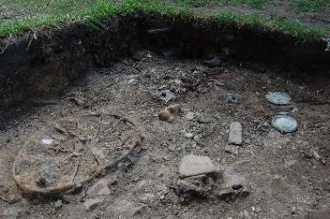
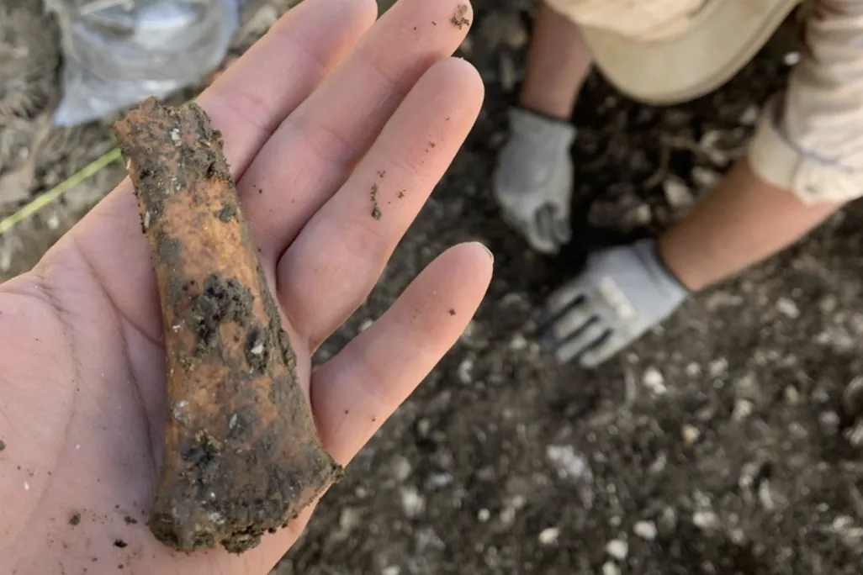
IMAGE 3 https://phys.org/news/2016-12-archaeologist-explores-african-americans-christianity.html
IMAGE 4 https://www.smithsonianmag.com/smart-news/jesuit-slave-quarters-unearthed-maryland-180976151/
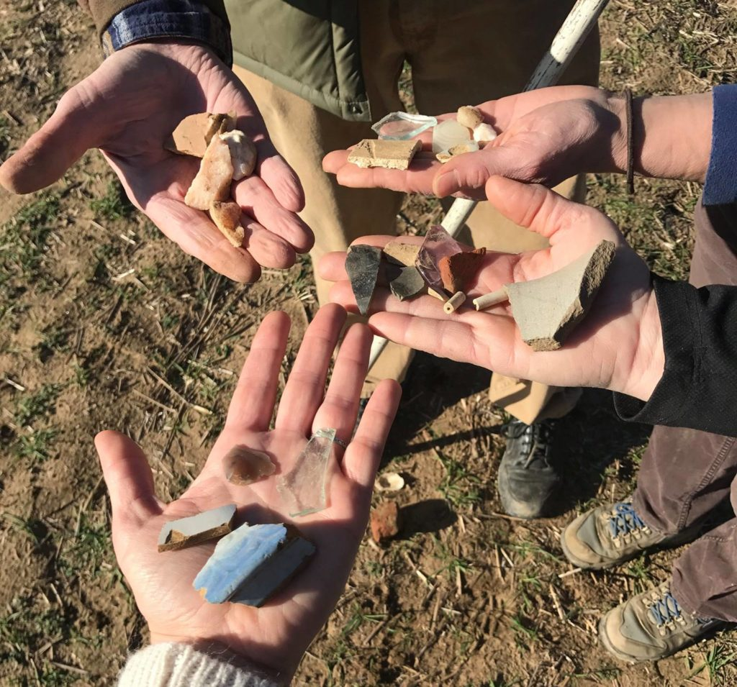
IMAGE 5
https://jugbay.org/inspire_events/the-archaeology-of-jug-bay-a-hike-through-history-6/
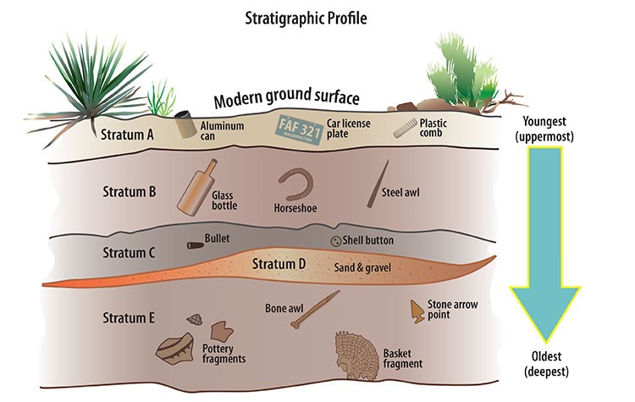
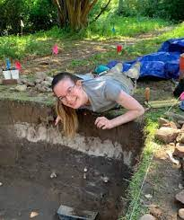
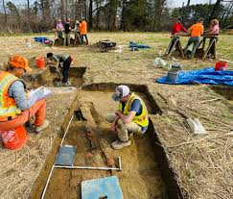
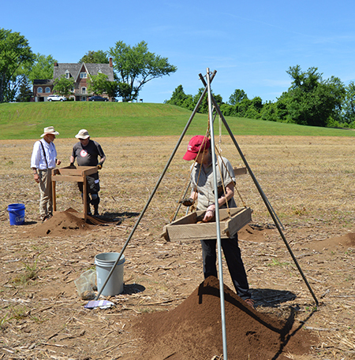
IMAGE 6 https://www.facebook.com/marylandarchaeology/
IMAGE 8
nmscarcheologylab.wordpress.com
Stratigraphic IMAGE 1:
https://www.southalabama.edu/org/archaeology/news/stratigraphy.html
IMAGE 7 https://mht.maryland.gov/Pages/archaeology/archaeology.aspx

