Trowels to Teaching Lesson Plan

AP World or US History DBQ
AP World: Units 4-5
AP US: Unit 5

PROMPT: Compare the strategies used by Native American societies and European settlers to manage political and cultural interaction in the Americas during the period 1450–1900.
In your response, consider how each group approached cultural preservation or transformation, engaged with prevailing economic systems, and the extent to which their strategies reflected broader patterns of colonialism, resistance, and adaptation.

Document 1:
Source: Weeping Woman Pendant, E.J. Neiburger, Central States Archaeological Journal, 2021, Vol 68, Issue 4, p200
EBSCO

“By the seventeenth century, Northeast tribes, such as the Seneca, Cayuga, and Onondaga, hammered, shaped, and cut European silver coins for jewelry. The more intricate techniques of silverworking were introduced to the Southwest Navajo by Mexican silversmiths during the early second half of the nineteenth century. Later, the Zuni (Pueblo) learned the craft from the Navajo. The Navajo style was distinguished by die-stamp designs that showed off the metal itself. Zuni work was more intricate in detail, and die work was rarer.”

Document 2:
Source: Provincial Court Land Records, 1719-1723, Volume 721, Page 408-409.
https://msa.maryland.gov/megafile/msa/speccol/sc2900/sc2908/000001/000721/html/am721--409.html

“It is agreed that from this day Forward there be an inviolable peace and amity between the Right Honble the Lord Propry of this province and the said Kings of Pocomoke and Assateague upon articles hereafter in this treaty to be agreed upon to the worlds end to endure and all former Acts of Hostility and damages whatsoever sustaind to be buryed in perpetuall oblivion That if any Indian subject to the said Kings shall hereafter kill and English man the said Kings shall be oblidgd to deliver such Indian up to the Governour of this province as a prisoner Forasmuch as the English cannot easily distinguish one Indian from another that no Indian shall come into any English plantatcon painted and that all the Indians shall be bound to call aloud before they come within three hundred paces of any English Mans Clear Ground and lay down their Arms whether guns Bows and Arrows or other Weapons for any Englishman that shall appear upon their call to take up and in case that no one appears that they shall there leave their ^said^ Arms.”

Document 3:
Source: Before and After photos of Native children at the Carlisle Indian Industrial School in Pennsylvania, circa 1900, Dickinson College Archives
https://www.kare11.com/gallery/news/local/archives-the-faces-of-native-american-boarding-schools/89-80fb89be-e71f-48dd-82d3-dd23cd3db5d8
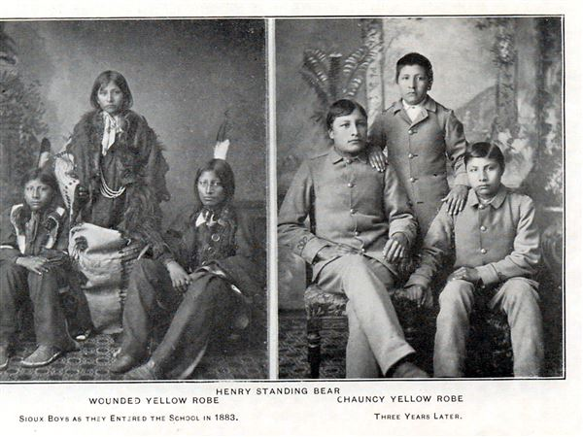
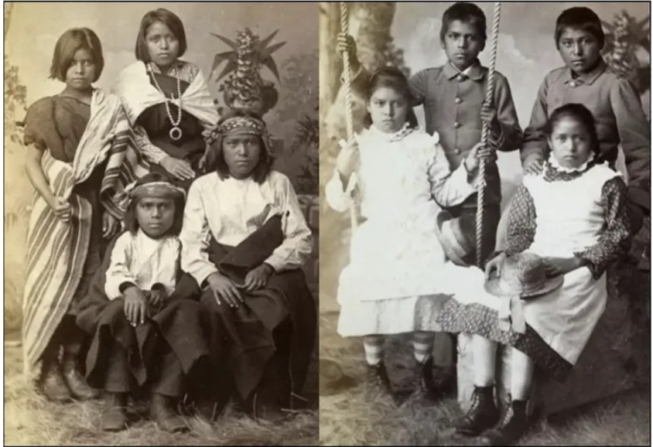

Document 4:
Source: “Jefferson’s Excavation of a Native American Burial Ground”, Monticello.org
The mound excavated by Jefferson is on the right (south) bank of the South Fork of the Rivanna River just north of Charlottesville and has been explored by archaeologists on several occasions, most recently by members of the Anthropology Department of the University of Virginia.[22] However, as early as 1911, Bushnell explored the area and reported that the mound had "entirely disappeared," most likely washed away due to flooding in the lowland where Jefferson found it.[23] The associated Monacan village of Monasukapanough probably occupied both banks of the South Fork at this point.[24] Research at this site is ongoing.[25]
The original territory of the Monacan Indian Nation and their allies once "comprised more than half the state of Virginia, including almost all of the Piedmont region and parts of the Blue Ridge Mountains." These Indigenous people were mound builders, placing the remains of their dead over time in sacred earthen graves.[26] Charles Thomson gave an eyewitness account of these burial rituals as part of his extensive comments on a draft of Jefferson's Notes, which Jefferson included as an appendix to Notes.[27]
Jefferson's excavation of the burial mound earned him the title of "Father of American Archaeology" and "first American archaeologist" by many scholars.[28] His systematic trenching and use of stratigraphy (i.e., stratigraphic observation) as part of his exploration of the burial mound "anticipates the fundamental approach and the methods of modern archaeology by about a full century."[29]

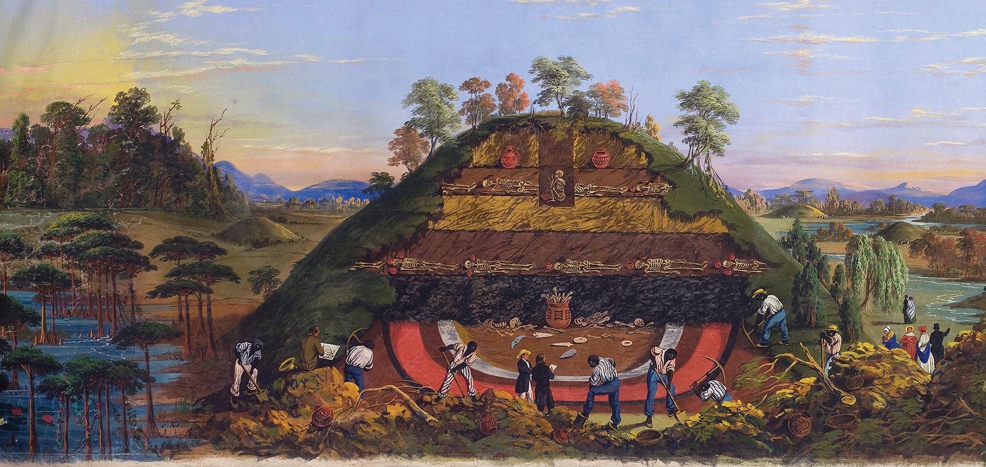

Document 5:
Source: Passages and Pathways: World Geography Part 2, 2025 Smith Gibbs Education, Page 235
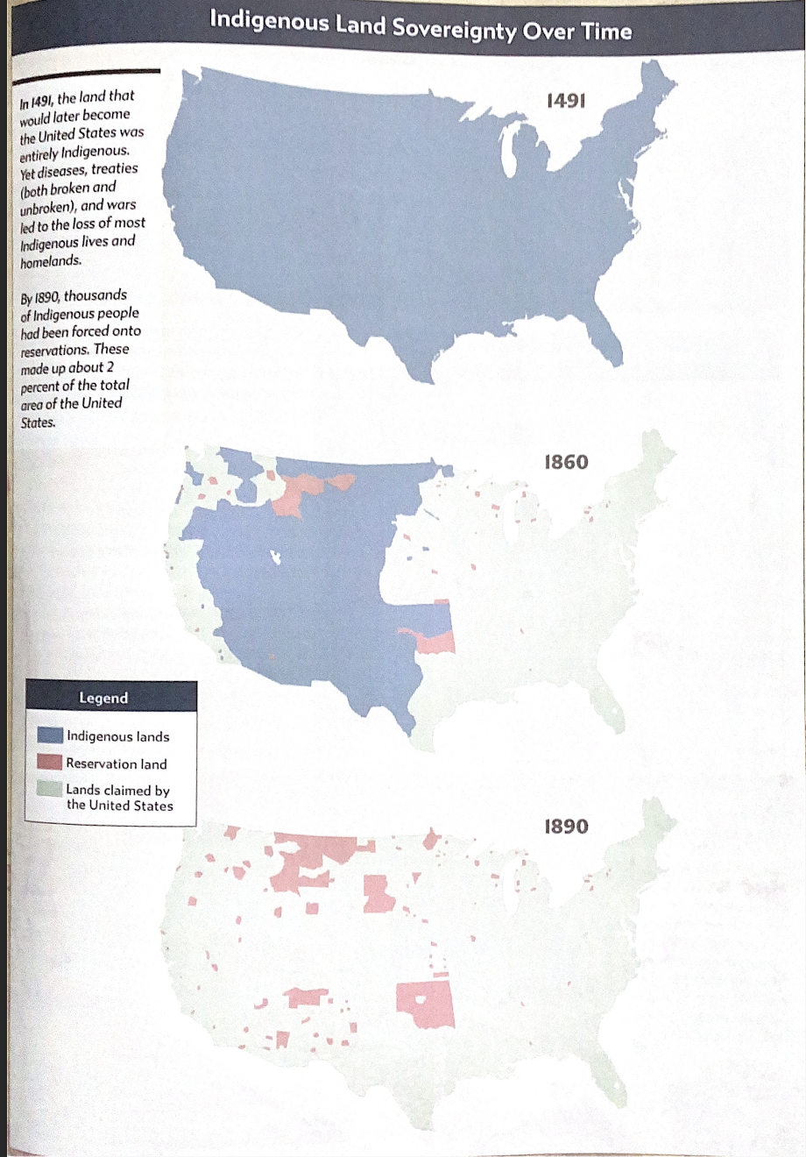

Document 6:
Source: Port Tobacco times, and Charles County advertiser., July 29, 1887; “Old Deeds” This short news item tells of deeds of land sold by the Piscataway. The deeds are viewed as relics because the author believed that “not a trace” of the Piscataway people remained in Maryland.
https://chroniclingamerica.loc.gov/lccn/sn89060060/1887-07-29/ed-1/seq-3/

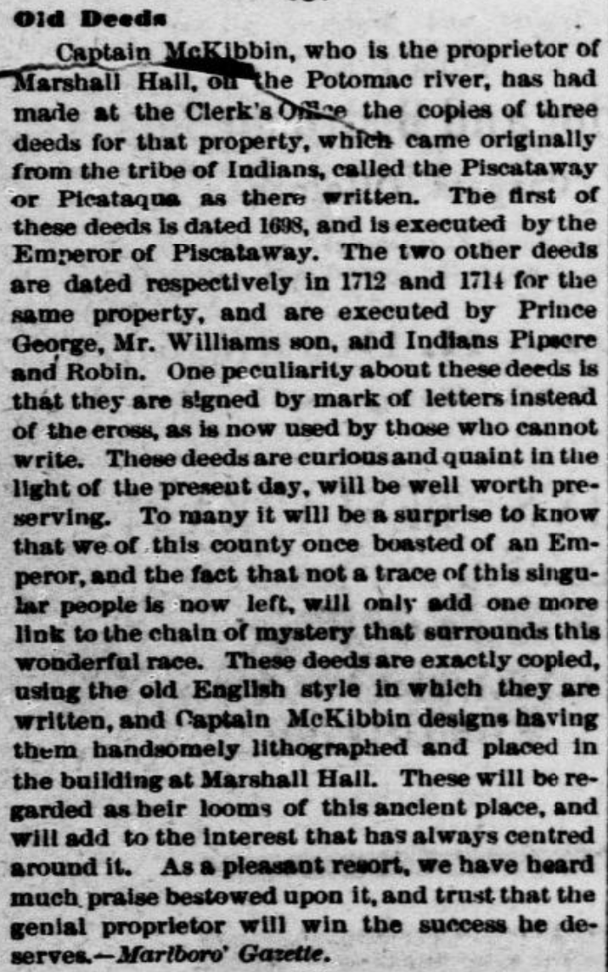

Document 7:
Source: Proceedings of the Council of Maryland 1636-1667, Volume 3,
This state council record tells that the Queen of Portaback and her tribe want to leave their lands. They were facing famine yearly when English settlers' livestock would graze in their cornfields.
https://msa.maryland.gov/megafile/msa/speccol/sc2900/sc2908/000001/000003/html/am3--489.html
By the Lieutenant General
“Whereas sundry complaints have been made unto me by the Queen of Portaback on behalf of herself and the Indians under her, intimating that they have not only left their town standing by the water, but have removed themselves
Liber H. H.
farther off—even to the utmost bounds of their land—leaving place for the English to settle on their ancient plantations by the riverside. The English, not being (as they inform me) content with what land is already freely granted, do still take up land and settle themselves very near unto the said Indians, whose stocks of cattle and hogs do and will yearly destroy their cornfields. By which means they must, of necessity, come to famine, they not knowing the way and means to fence in their cornfields as the English do, and will soon come to destruction.
I do therefore hereby will and require all persons whatsoever, inhabitants of this province, to take notice hereof and desist from taking up any land or settling any land (though formerly taken up and surveyed by them) within three miles at the least of any of the said Indian habitations or plantations.”
Given under my hand this 17th day of November 1663.

