Before Contact: Geography, Culture, and Native Life along the Patuxent
Unit: Colonization (1607–1754)
Topic: Interactions in the New World
Grade Level: 8th Grade
Length: 1–2 class periods (can be adapted for block or standard periods)

Standards & Objectives
Indicator:
Students will evaluate the interaction of European, African, and Native cultures in colonial America by:
Objective:
Describing the varied cultures and geographic distribution of Native populations in North America prior to European arrival.

Essential Question(s)
From Framework
How did European exploration and colonization result in cultural and economic interactions among previously unconnected peoples?
Lesson Specific
How did the geography and environment of the Chesapeake region affect the distribution and culture of Native Americans before the arrival of Europeans?

Materials
- Student Handout: Before Contact: Geography, Culture, and Native Life along the Patuxent
- Adapted excerpt from John Smith’s The Generall Historie of Virginia (1624) and The True Adventures and Observations of Captain John Smith (1630)
- Map of John Smith’s Virginia: Discovered and Described (1612)
- Archaeological article: Investigations at the Cumberland Site in Calvert County (adapted)
- Diagnostic Artifact Websites:
  - Prehistoric Ceramics in Maryland
  - Projectile Points in Maryland

Warm-Up (5-10 minutes)
Prompt (on board or slide):
How do we learn about events we didn’t witness ourselves?
What makes it harder to learn about events from the distant past?
Students will respond individually, then engage in a brief class share-out. Encourage students to consider evidence, storytelling, bias, and preservation.

Task 1: Analyzing a Written and Visual Source (10-15 minutes)
Students read the adapted excerpt from John Smith’s journal and examine a copy of his 1612 map.
Guided Questions:
- What did you learn about the tribes John Smith encountered?
- What do we need to consider about who John Smith was and why he wrote this account?
Students will source and close read the primary document. They will begin to think about geography and cultural observations.

Task 2: Archaeological Investigations (30-45 minutes)
Students read the article Investigations at the Cumberland Site in Calvert County (adapted)
Guided Questions:
- Describe the village layout and why it might have been designed that way.
- What do you notice about family or community structures? Defense? Access to natural resources?

Artifact Analysis
Students review the ceramics, lithic artifacts, and faunal remains using both the article and supporting online resources.
Students complete the table in the handout:
- What can these artifacts tell us about when people lived there?
- How did people use the environment to survive and shape their culture?

Conclusion question:
What conclusions can you make based on the corroborating evidence across different types of artifacts?
Students will continue working on the goal of corroboration and interpretation of material culture helping students think holistically about life before European contact.

Reflection (15-20 minutes)
Comparing Sources
Students compare the two sources (John Smith’s written account and the archaeological evidence) using guiding prompts:
- How do the two sources compare?
- What information is similar, different, or missing?
- What seems more reliable? Why?
- What do these sources together tell us that one alone would not?
Students focus on sourcing, corroboration, and contextualization as historical thinking tools.

Essential question
Students will write 2–3 sentences explaining how the land and environment of the Chesapeake region shaped Native American life before Europeans arrived.
Guided Questions:
- What natural resources were available?
- How were these used to meet needs?
- What was their family and community structure?
- How did they modify the environment?
- What were major cultural aspects?
Students reflect on the essential question from this lesson and can begin to place it into the larger historical context of the Chesapeake Bay region.

John Smith’s Description of meeting Native Americans on Patuxent River
The Generall Historie of Virginia (1624) and The True Adventures and Observations of Captain John Smith (1630)
Source: https://www.loc.gov/resource/lhbcb.0262a/?st=pdf&pdfPage=70

Original Source
Pawtuxunt, R
The fift river is called Pawtuxunt, of a lesse proportion then the rest; but the channell is16 fadome deepe in some places. Here are infinit skuls of divers kindes of fish more then elswhere. Upon this river dwell the people called Acquintanacksuak, Pawtuxunt, and Mattapanient. Two hundred men was the greatest strength that could be there perceived. But they inhabit together, and not so dispersed as the rest. These of all other we found most civill to give intertainement

Adapted Source
Pawtuxunt River (Spelt today as Patuxent)
The fifth river is called Pawtuxunt, of a lesser proportion then the rest; but the channel is 16 fathoms deep (fathom equals 6 feet; therefore 16 x 6 = 96 feet deep) in some places. Here are infinite schools of diverse kinds of fish more then elsewhere. Upon this river dwell the people called Acquintanacksuak, Pawtuxunt, and Mattapanient. Two hundred men was the greatest strength that could be there perceived. But they inhabit together, and not so dispersed as the rest. These of all other we found most civil to give entertainment.

John Smith’s Map of Virginia
Virginia: Discovered and Described, John Smith (1612)
Source: https://www.loc.gov/item/99446115/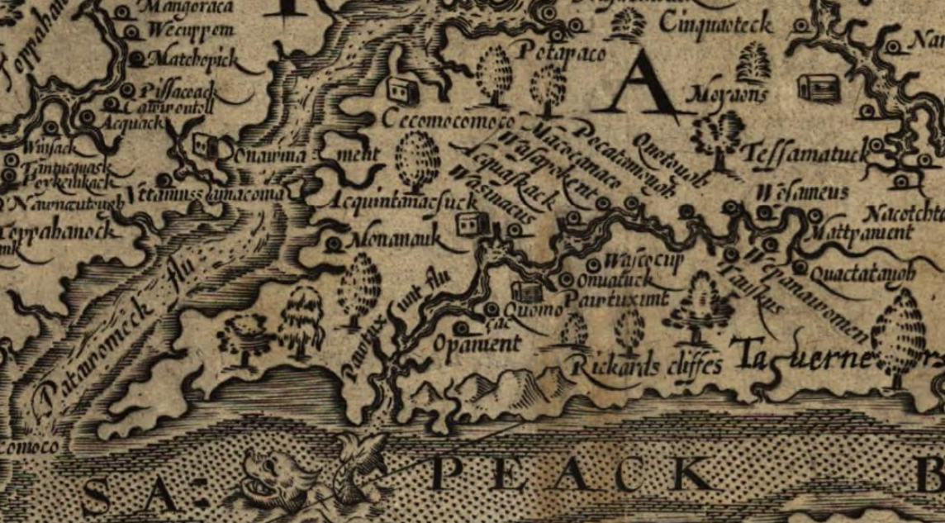

Archaeological Investigations at the Cumberland Site in Calvert County
Adapted from https://colonialencounters.org/SiteSummaries/CumberlandSummary.aspx
Initial Discovery
The Cumberland Site was discovered by Richard Stearns in the 1930s. The survey of the site was cursory, focused on locating and mapping shell middens, and included no investigation below the ground.
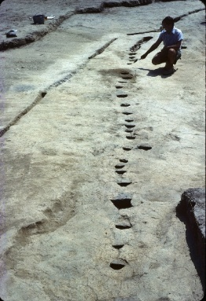
Renewed Interest Sparks Investigation
In 1982, the Cumberland family notified the Maryland Historical Trust (MHT) that they were planning to construct a house on a portion of the site. In May of that year, Michael Smolek from MHT's Southern Maryland Regional Center conducted initial investigations. Smolek first performed a quick controlled surface collection, collecting artifacts from across an agricultural field. To check for possible remains below the ground, Smolek dug 30 shovel test pits, these test pits would give an idea if there was anything of importance buried underground. One shovel test pit revealed what appeared to be an old post. He continued and traced 76 meters of what appeared to be a palisade (wall).

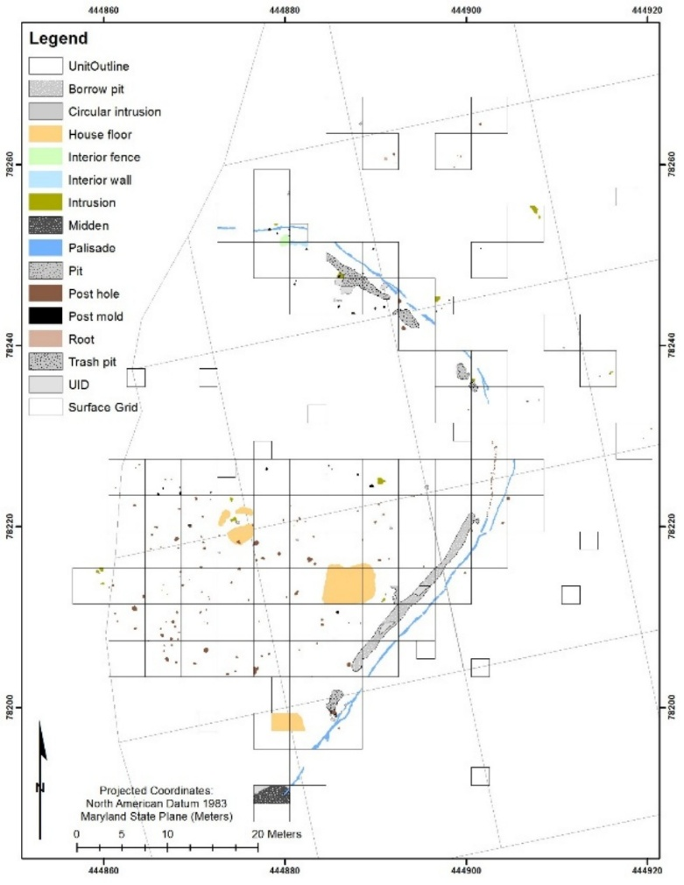
Fieldwork in Full Swing
In May 1983, the site was divided into 400 4-by-4 meter squares and artifacts were surface collected, eventually 42 of these squares were excavated to collect soil samples and artifacts. An excavator was then used to mechanically remove the plow zone on the portion of the site to be impacted by house construction, an area measuring approximately 24 by 48 meters in size. The relative lack of features, such as postholes and pits, is probably the result of the land having been plowed for a number of years, while clusters of artifacts outside the palisade may represent additional settlement or activity areas. The use of the excavator revealed the presence of about 44 meters of filled ditch, which contained most of the site's artifacts.

Artifacts
A total of 86,935 artifacts were recovered from the Cumberland Site, not including the materials from the surface collection and shovel test pits excavated in 1982. All artifacts appear to date before European contact, as no European trade material was recovered.

Ceramics
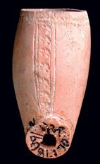
Ceramic (clay) objects recovered from the Cumberland Site included 5,593 ceramic fragments, while many ceramic fragments could not be formally typed the following were identified:
- 2,659 Townsend Series sherds
- 119 Mockley sherds
- 1 sand-tempered fragment with a hole drilled in its center might represent a ceramic ornament.
- 9 red clay tobacco pipe fragments

Of these fragments over 4,900 fragments exhibit no surface treatment, however:
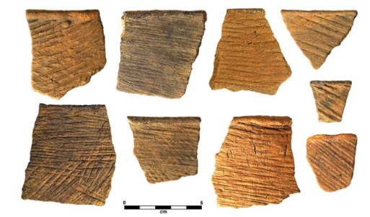
- 268 were fabric-impressed
- 42 net-impressed
- 34 cord-marked
- 9 smoothed-over cord-marked
- 5 smoothed
- 2 incised

Lithic Artifacts
A total of 4,206 lithic (stone) artifacts were recovered, with quartz, quartzite, chert, sandstone, and rhyolite the predominant materials.

59 projectile points and point fragments were found (all were recovered from within the palisade) those that could be identified are as follows:
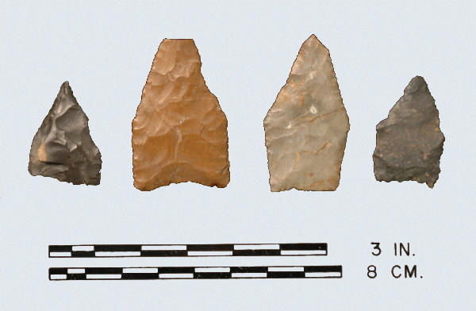
- 1 St. Albans
- 1 Morrow Mountain
- 2 Bare Island
- 1 Orient Fishtail
- 1 Jack's Reef Pentagonal
- 1 Madison
- 6 Levanna
- 7 Potomac

Other Tools
- 25 bifaces
- 2 scrapers
- 1 spokeshave (tool to make wooden rods)
- 5 hammerstones

Faunal Materials
66,433 faunal items, those pertaining to animals, were recovered at the Cumberland
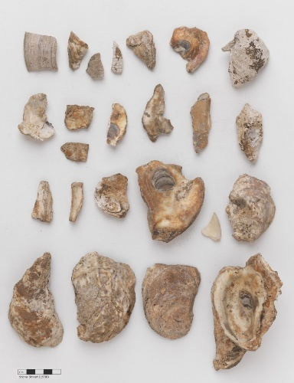
- 64,842 oyster shell fragments making up the majority of the items
- Snail, clam, periwinkle, mussel, and unidentified shells were also recovered in limited quantities.
- A barrel-shaped shell bead was the only worked shell item recovered during excavations, while a shark's tooth, probably worn as a pendant.
- 811 animal bones, including teeth, bones, fish scales, turtle shells, and antlers, were recovered.

Name: _____________________________
Before Contact: Geography, Culture, and Native Life along the Patuxent
Essential Question: How did the geography and environment of the Chesapeake region affect the distribution and culture of Native Americans before the arrival of Europeans?

Warm-up:
How do we learn about events, that we weren’t there to see ourselves?

What makes it harder to learn about events that happened in the past?

Task 1:
Directions: Examine the two sources: “John Smith’s Description of meeting Native Americans on Patuxent River” about John Smith’s account of traveling up the Patuxent River and meeting the Native American tribes. “John Smith’s Map of Virginia”, which is a map that he made based on his expeditions throughout the Chesapeake region

Describe what did you learn about the Native American tribes that John Smith encountered along the Patuxent River?

What should we keep in mind when reading Smith’s description of these tribes and his map? (Think about sourcing of the documents)

Task 2:
Directions: Begin reading the “Archaeological Investigations at the Cumberland Site in Calvert County”. Read the first 3 sections and analyze the archaeological diagram of the village, answer the following questions.

Briefly describe the layout of the village. (Think about, where the structures were built…pits included!?)

Based on the layout of the village make an inference:
Why was it built this way? (Think about, what can this tell us about life and familial structure? What can this tell us about interactions with other people?)

Directions: As you start reading the section titled “Artifacts”, use the following web sources to gain further insight into the people who lived at this site and answer the questions that follow.
Types of Artifacts | When were people living there? (Think about the time periods, time of year, etc.) | How were the people using the environment to support themselves and contribute to their culture? (Think about the materials and resources used/available)
Ceramics
Diagnostic Artifacts Maryland | Prehistoric Ceramics in Maryland
Lithic Artifacts
Diagnostic Artifacts Maryland | Projectile Points

Faunal Materials

What conclusions can you make? (Think about the corroborating evidence from the artifacts)

Reflection
Comparing sources:
How do the two sources compare in the information they provide about the Native Americans who lived here? (Think about what they agree on, what is different, what is information that is missing, what is the reliability of the sources)

Essential Question:
How did the geography and environment of the Chesapeake region affect the distribution and culture of Native Americans before the arrival of Europeans? (Think about the inferences you made during Task 2 from the different artifacts, and how they corroborate to further strengthen your inferences)

